Assignment 3 Report

Test Six was my final product. In test six I unfroze layer four and lowered the learning rate by 100x in order to preserve pretrained backbone statistics. The improvement was immediate and dramatic but didn’t present itself as overfitting and exceeded expectations of 88% accuracy by scoring a 91.7% on test accuracy
Train and validation converged well and lead to my highest accuracies across the board with clear smooth curves
The final misclassified examples are all very close to their correct answer and I believe they are wrong due to resolution loss or cropping etc., with no super obvious mistakes or outliers
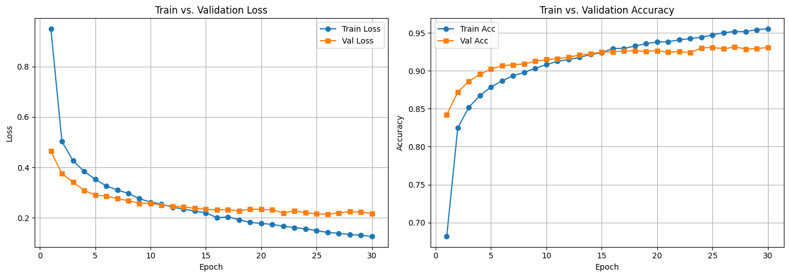
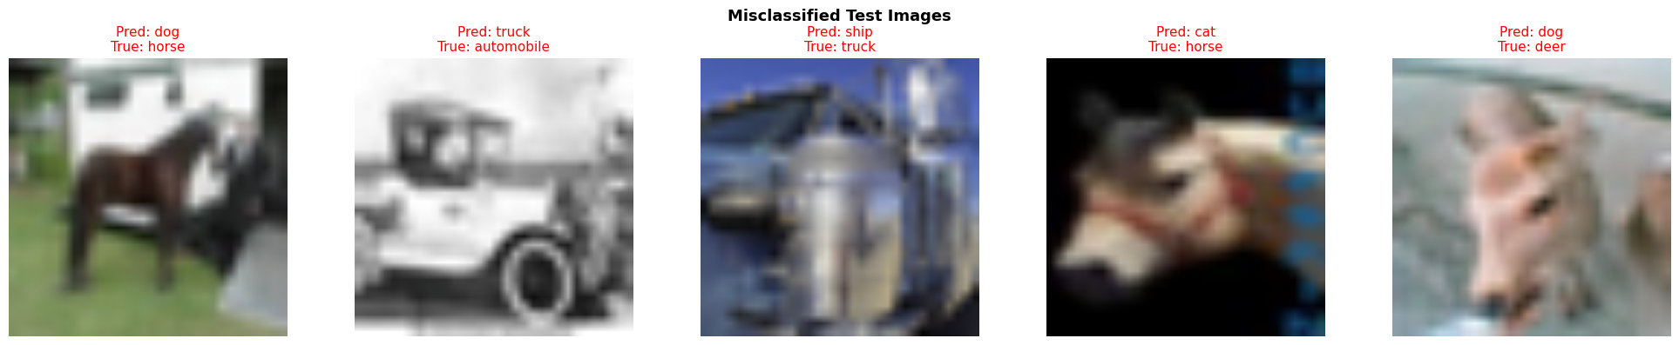
Test one:
BATCH_SIZE = 256, EPOCHS = 10 , LR = 5e-2, WEIGHT_DECAY = 1e-4
With RandomHorizontalFlip(),
Epoch 01/10 | train loss=2.5716 acc=0.6749 | val loss=0.8280 acc=0.7628
Epoch 02/10 | train loss=0.8584 acc=0.7576 | val loss=0.8534 acc=0.7538
Epoch 03/10 | train loss=0.8787 acc=0.7576 | val loss=1.0229 acc=0.7488
Epoch 04/10 | train loss=0.9286 acc=0.7604 | val loss=0.9099 acc=0.7632
Epoch 05/10 | train loss=0.9716 acc=0.7542 | val loss=0.7924 acc=0.7892
Epoch 06/10 | train loss=0.9380 acc=0.7643 | val loss=1.0780 acc=0.7600
Epoch 07/10 | train loss=1.0174 acc=0.7559 | val loss=1.0096 acc=0.7626
Epoch 08/10 | train loss=1.0034 acc=0.7604 | val loss=0.8299 acc=0.7924
Epoch 09/10 | train loss=1.1413 acc=0.7536 | val loss=1.5306 acc=0.7158
Epoch 10/10 | train loss=1.0558 acc=0.7654 | val loss=1.0406 acc=0.7554
Best epoch: 8 Best val acc: 0.7924
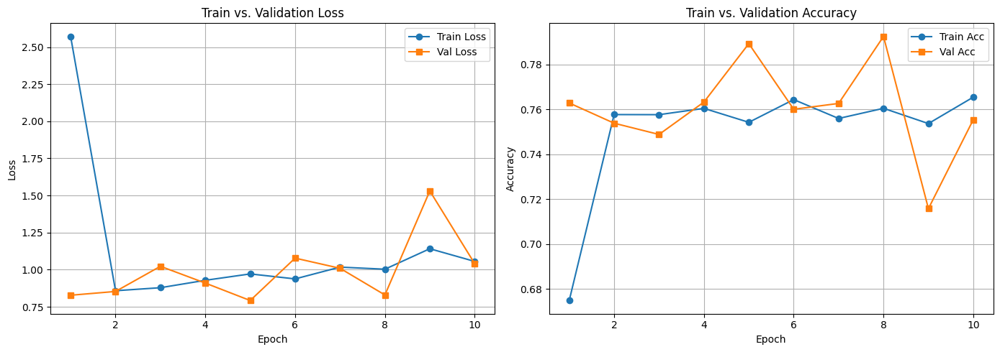
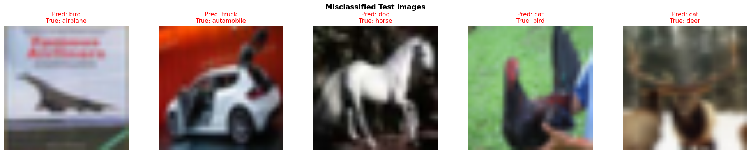
The plots are both very jumpy by the overall accuracies are not bad and that is reflected in the misclassified images as most are very closely resembling their misclassification
Test Two:
BATCH_SIZE = 512, LR = 3e-3, WEIGHT_DECAY = 1e-3, added colorjitter and randrotation
Epoch 01/10 | train loss=1.2106 acc=0.6068 | val loss=0.6990 acc=0.7748
Epoch 02/10 | train loss=0.8072 acc=0.7298 | val loss=0.6174 acc=0.7908
Epoch 03/10 | train loss=0.7483 acc=0.7451 | val loss=0.5958 acc=0.7988
Epoch 04/10 | train loss=0.7299 acc=0.7472 | val loss=0.5762 acc=0.8068
Epoch 05/10 | train loss=0.6999 acc=0.7586 | val loss=0.5736 acc=0.8046
Epoch 06/10 | train loss=0.6986 acc=0.7608 | val loss=0.5730 acc=0.8036
Epoch 07/10 | train loss=0.6909 acc=0.7622 | val loss=0.5550 acc=0.8076
Epoch 08/10 | train loss=0.6869 acc=0.7636 | val loss=0.5601 acc=0.8054
Epoch 09/10 | train loss=0.6750 acc=0.7673 | val loss=0.5648 acc=0.8080
Epoch 10/10 | train loss=0.6778 acc=0.7668 | val loss=0.5516 acc=0.8118
Best epoch: 10 Best val acc: 0.8118
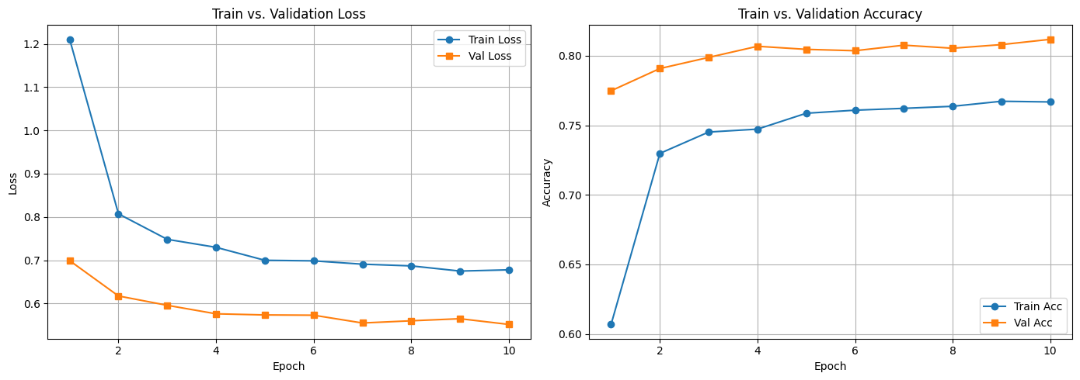
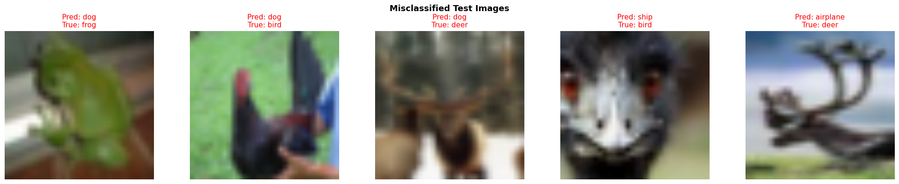
Both curves have smoothed out but there is no real increase in accuracies and the the val and train are getting too far apart as seen in the misclassified images where there are more examples that are far off of the correct classification
Test three:
Expanded the head by changing to a small MLP head
Epoch 01/10 | train loss=1.1389 acc=0.6044 | val loss=0.6872 acc=0.7624
Epoch 02/10 | train loss=0.8090 acc=0.7209 | val loss=0.6068 acc=0.7914
Epoch 03/10 | train loss=0.7825 acc=0.7306 | val loss=0.6226 acc=0.7910
Epoch 04/10 | train loss=0.7680 acc=0.7340 | val loss=0.5767 acc=0.8072
Epoch 05/10 | train loss=0.7513 acc=0.7385 | val loss=0.5709 acc=0.8012
Epoch 06/10 | train loss=0.7507 acc=0.7389 | val loss=0.5475 acc=0.8114
Epoch 07/10 | train loss=0.7427 acc=0.7430 | val loss=0.5722 acc=0.8044
Epoch 08/10 | train loss=0.7435 acc=0.7442 | val loss=0.5538 acc=0.8086
Epoch 09/10 | train loss=0.7298 acc=0.7470 | val loss=0.5241 acc=0.8230
Epoch 10/10 | train loss=0.7253 acc=0.7499 | val loss=0.5588 acc=0.8044
Best epoch: 9 Best val acc: 0.823
Saved best checkpoint to: best_resnet18_head_cifar10.pt
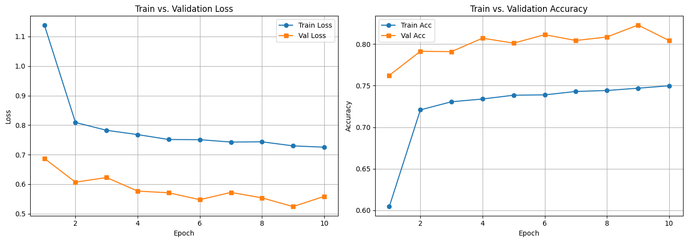
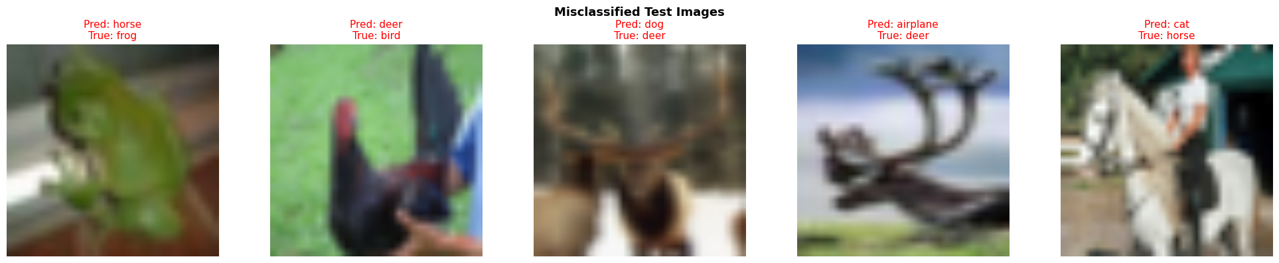
Accuracy went up again but the difference is still concerning
Loaded best checkpoint from epoch 9 (val_acc=0.8230)
Final validation accuracy: 0.8230 (loss=0.5241)
Final test accuracy: 0.8044 (loss=0.5614)
Test four:
Lowered transformation parameters including brightness contrast and saturation as well as the random rotation
Epoch 01/10 | train loss=1.0640 acc=0.6324 | val loss=0.6817 acc=0.7698
Epoch 02/10 | train loss=0.7614 acc=0.7356 | val loss=0.5840 acc=0.7978
Epoch 03/10 | train loss=0.7279 acc=0.7468 | val loss=0.5934 acc=0.7956
Epoch 04/10 | train loss=0.7157 acc=0.7499 | val loss=0.5466 acc=0.8132
Epoch 05/10 | train loss=0.7058 acc=0.7529 | val loss=0.5476 acc=0.8128
Epoch 06/10 | train loss=0.7042 acc=0.7564 | val loss=0.5244 acc=0.8222
Epoch 07/10 | train loss=0.6981 acc=0.7561 | val loss=0.5366 acc=0.8178
Epoch 08/10 | train loss=0.6970 acc=0.7601 | val loss=0.5498 acc=0.8104
Epoch 09/10 | train loss=0.6869 acc=0.7603 | val loss=0.5181 acc=0.8182
Epoch 10/10 | train loss=0.6834 acc=0.7633 | val loss=0.5249 acc=0.8144
Best epoch: 6 Best val acc: 0.8222
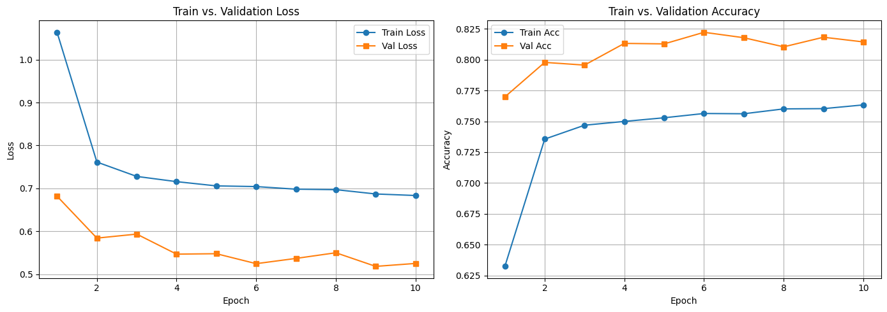
Loaded best checkpoint from epoch 6 (val_acc=0.8222)
Final validation accuracy: 0.8222 (loss=0.5244)

Final test accuracy: 0.8110 (loss=0.5503) 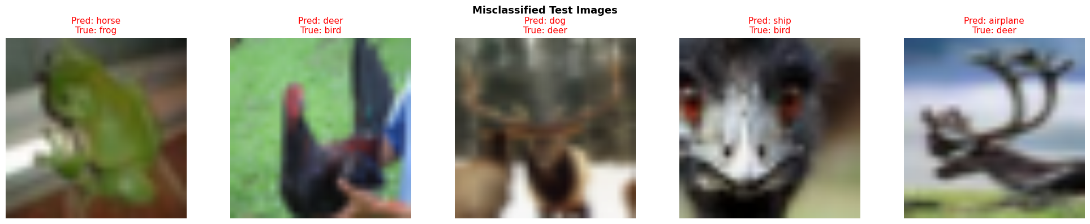
Overall better still want to decrease the accuracy gap and the misclassified images have not gotten better
Test five:
Increasing epochs to 20 and changing learning rate to 1e^-3 from 3e^-3
Also lowering random rotation again to 5
Epoch 01/20 | train loss=1.1054 acc=0.6330 | val loss=0.6611 acc=0.7794
Epoch 02/20 | train loss=0.7399 acc=0.7470 | val loss=0.5741 acc=0.8046
Epoch 03/20 | train loss=0.6890 acc=0.7636 | val loss=0.5536 acc=0.8096
Epoch 04/20 | train loss=0.6618 acc=0.7709 | val loss=0.5575 acc=0.8074
Epoch 05/20 | train loss=0.6486 acc=0.7756 | val loss=0.5252 acc=0.8152
Epoch 06/20 | train loss=0.6344 acc=0.7814 | val loss=0.5413 acc=0.8138
Epoch 07/20 | train loss=0.6325 acc=0.7817 | val loss=0.5299 acc=0.8146
Epoch 08/20 | train loss=0.6269 acc=0.7836 | val loss=0.5328 acc=0.8162
Epoch 09/20 | train loss=0.6096 acc=0.7874 | val loss=0.5192 acc=0.8166
Epoch 10/20 | train loss=0.6017 acc=0.7920 | val loss=0.5024 acc=0.8274
Epoch 11/20 | train loss=0.6001 acc=0.7925 | val loss=0.5054 acc=0.8246
Epoch 12/20 | train loss=0.5952 acc=0.7939 | val loss=0.5061 acc=0.8242
Epoch 13/20 | train loss=0.5965 acc=0.7927 | val loss=0.5011 acc=0.8234
Epoch 14/20 | train loss=0.5880 acc=0.7944 | val loss=0.4825 acc=0.8306
Epoch 15/20 | train loss=0.5806 acc=0.7978 | val loss=0.4933 acc=0.8270
Epoch 16/20 | train loss=0.5756 acc=0.8014 | val loss=0.4770 acc=0.8348
Epoch 17/20 | train loss=0.5744 acc=0.8013 | val loss=0.5000 acc=0.8262
Epoch 18/20 | train loss=0.5713 acc=0.8029 | val loss=0.5033 acc=0.8252
Epoch 19/20 | train loss=0.5678 acc=0.8034 | val loss=0.4785 acc=0.8358
Epoch 20/20 | train loss=0.5733 acc=0.7987 | val loss=0.4791 acc=0.8320
Best epoch: 19 Best val acc: 0.8358
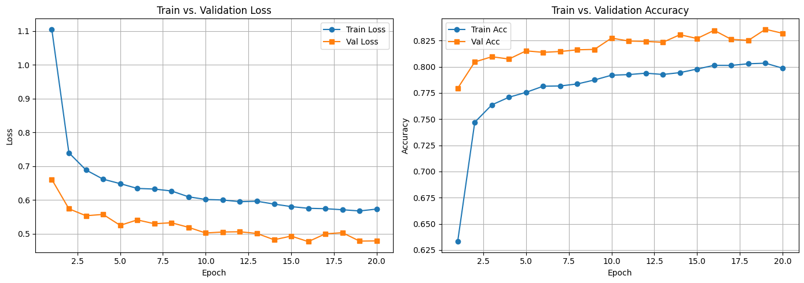
Loaded best checkpoint from epoch 19 (val_acc=0.8358)
Final validation accuracy: 0.8358 (loss=0.4785)
Final test accuracy: 0.8191 (loss=0.5189)
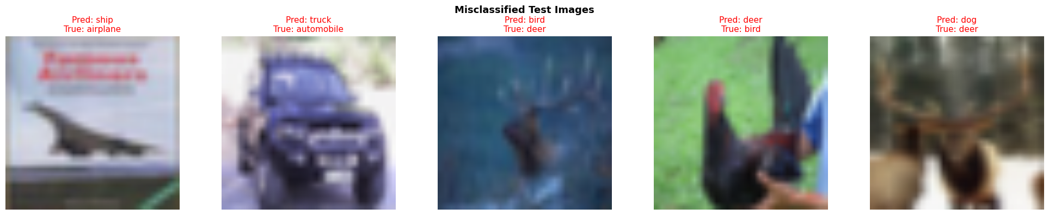
Much cleaner plots and the train and val gap has decreased making me feel more comfortable about the results. Also the misclassified images are closer to their true classification then the three previous tests signaling some increase in learning
Test six:
Increased to 30 epochs
Unfroze layer 4
And lowered LR for layer 4 in the Adam optimizer
Epoch 01/30 | train loss=0.9498 acc=0.6816 | val loss=0.4648 acc=0.8424
Epoch 02/30 | train loss=0.5029 acc=0.8250 | val loss=0.3755 acc=0.8720
Epoch 03/30 | train loss=0.4268 acc=0.8520 | val loss=0.3420 acc=0.8864
Epoch 04/30 | train loss=0.3847 acc=0.8674 | val loss=0.3096 acc=0.8954
Epoch 05/30 | train loss=0.3529 acc=0.8787 | val loss=0.2906 acc=0.9024
Epoch 06/30 | train loss=0.3272 acc=0.8867 | val loss=0.2864 acc=0.9066
Epoch 07/30 | train loss=0.3107 acc=0.8936 | val loss=0.2765 acc=0.9080
Epoch 08/30 | train loss=0.2969 acc=0.8978 | val loss=0.2681 acc=0.9090
Epoch 09/30 | train loss=0.2763 acc=0.9035 | val loss=0.2582 acc=0.9126
Epoch 10/30 | train loss=0.2623 acc=0.9080 | val loss=0.2573 acc=0.9148
Epoch 11/30 | train loss=0.2549 acc=0.9125 | val loss=0.2511 acc=0.9160
Epoch 12/30 | train loss=0.2418 acc=0.9149 | val loss=0.2466 acc=0.9178
Epoch 13/30 | train loss=0.2351 acc=0.9177 | val loss=0.2435 acc=0.9210
Epoch 14/30 | train loss=0.2272 acc=0.9215 | val loss=0.2382 acc=0.9224
Epoch 15/30 | train loss=0.2200 acc=0.9239 | val loss=0.2343 acc=0.9248
Epoch 16/30 | train loss=0.2011 acc=0.9294 | val loss=0.2318 acc=0.9250
Epoch 17/30 | train loss=0.2037 acc=0.9295 | val loss=0.2326 acc=0.9260
Epoch 18/30 | train loss=0.1930 acc=0.9326 | val loss=0.2278 acc=0.9264
Epoch 19/30 | train loss=0.1821 acc=0.9359 | val loss=0.2349 acc=0.9256
Epoch 20/30 | train loss=0.1784 acc=0.9380 | val loss=0.2337 acc=0.9266
Epoch 21/30 | train loss=0.1741 acc=0.9384 | val loss=0.2317 acc=0.9244
Epoch 22/30 | train loss=0.1670 acc=0.9408 | val loss=0.2197 acc=0.9254
Epoch 23/30 | train loss=0.1618 acc=0.9424 | val loss=0.2283 acc=0.9240
Epoch 24/30 | train loss=0.1567 acc=0.9443 | val loss=0.2204 acc=0.9302
Epoch 25/30 | train loss=0.1501 acc=0.9473 | val loss=0.2158 acc=0.9308
Epoch 26/30 | train loss=0.1421 acc=0.9504 | val loss=0.2150 acc=0.9290
Epoch 27/30 | train loss=0.1392 acc=0.9518 | val loss=0.2199 acc=0.9314
Epoch 28/30 | train loss=0.1340 acc=0.9519 | val loss=0.2250 acc=0.9288
Epoch 29/30 | train loss=0.1313 acc=0.9540 | val loss=0.2233 acc=0.9292
Epoch 30/30 | train loss=0.1264 acc=0.9555 | val loss=0.2172 acc=0.9308
Best epoch: 27 Best val acc: 0.9314
Saved best checkpoint to: best_resnet18_head_cifar10.pt

Loaded best checkpoint from epoch 27 (val_acc=0.9314)
Final validation accuracy: 0.9314 (loss=0.2199)
Final test accuracy: 0.9178 (loss=0.2601)

Train and validation converged well and lead to my highest accuracies across the board with clear smooth curves
The final misclassified examples are all very close to their correct answer and I believe are wrong due to resolution loss or cropping etc. with no super obvious mistakes or outliers

